JenkinsTask-03 (Task-2)

Task 2
Create one Jenkins job using the below code and create three stages:
- stage1: Git clone to download the source code.
- stage2: Sonarqube Integration to check the quality of code.
- stage3: Slack Integration to send the alerts to slack.
URL: https://github.com/betawins/hiring-app.git

Task Title
Jenkins CI Pipeline with GitHub, SonarQube Code Quality Analysis, and Slack Notifications
Overall Task Objective
To create a Jenkins job that automates the continuous integration process by pulling source code from a GitHub repository, performing static code quality analysis using SonarQube, and sending build status notifications to a Slack channel.
Prerequisites
- Jenkins server installed and running
- Jenkins user with admin access
- Git installed on Jenkins server
- Docker installed and running (for SonarQube)
- SonarQube server running on port 9003
- SonarQube Scanner installed on Jenkins server
- SonarQube authentication token generated
- Slack workspace created
- Jenkins app added to Slack workspace
- Slack Notification plugin installed in Jenkins
- Internet access from Jenkins server
- GitHub public repository access
https://github.com/betawins/hiring-app.git

stage1: Git clone to download the source code.
Steps Performed
1. Create a New Jenkins Job
- Opened Jenkins dashboard.
- Clicked New Item.
- Entered the job name as Betawins.
- Selected Freestyle project as the job type.
- Clicked OK to create the job.
2. Configure General Settings
- Navigated to Job → Configuration.
- In the General section:
  - Added Betawins in the Description field.
  - Left other options as default.
- Ensured the job was Enabled.
3. Configure Source Code Management (Git)
- Opened Source Code Management section.
- Selected Git.
- Entered the repository URL:
- https://github.com/betawins/hiring-app.git
- Left Credentials as none (public repository).
- Under Branches to build, entered:
- */main
4. Save Job Configuration
- Clicked Save to apply the configuration.
5. Trigger the Build
- From the job dashboard, clicked Build Now.
- Jenkins created Build #1.

6. Verify Build Execution
- Opened Build #1.
- Checked Console Output.
- Observed:
  - Job started by user unknown or anonymous.
  - Git repository was successfully cloned.
  - Code checked out from the main branch.
  - Build completed with SUCCESS status.
7. Confirm Job Status
- Returned to the job main page.
- Verified:
  - Green checkmark indicating successful build.
  - Build listed under Permalinks and Build History.
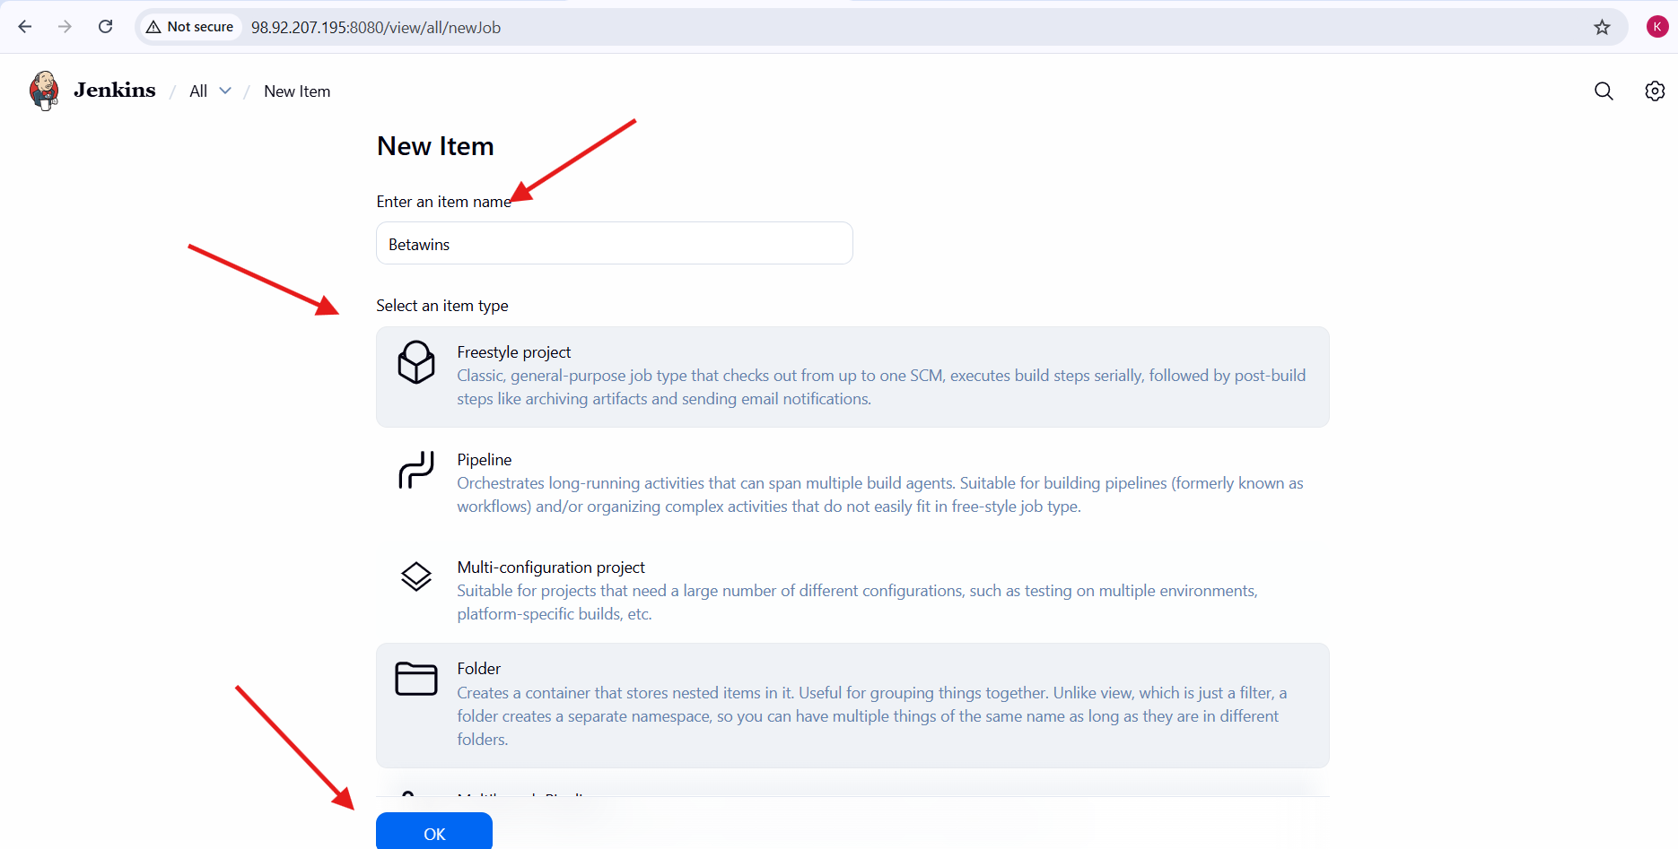
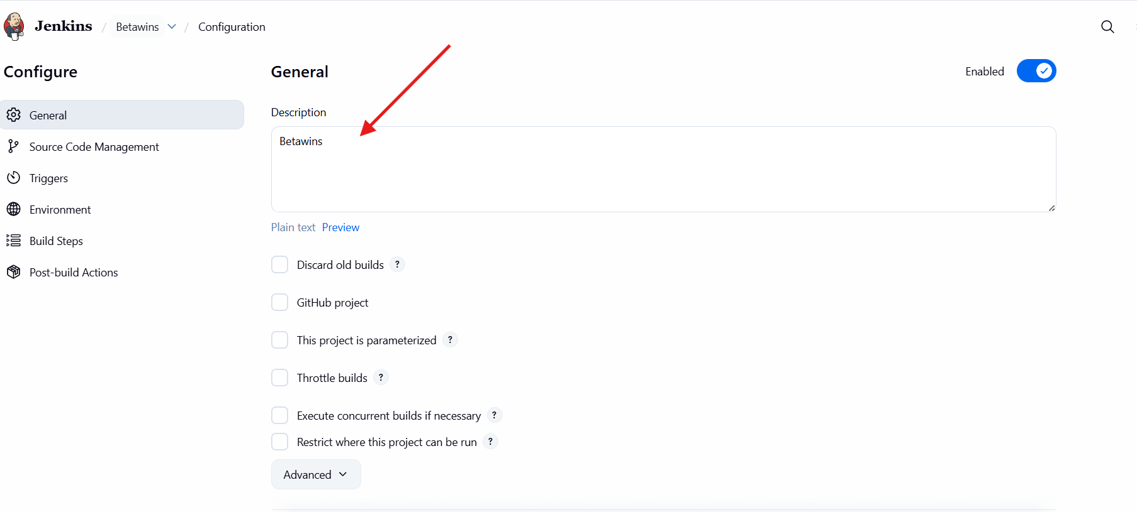
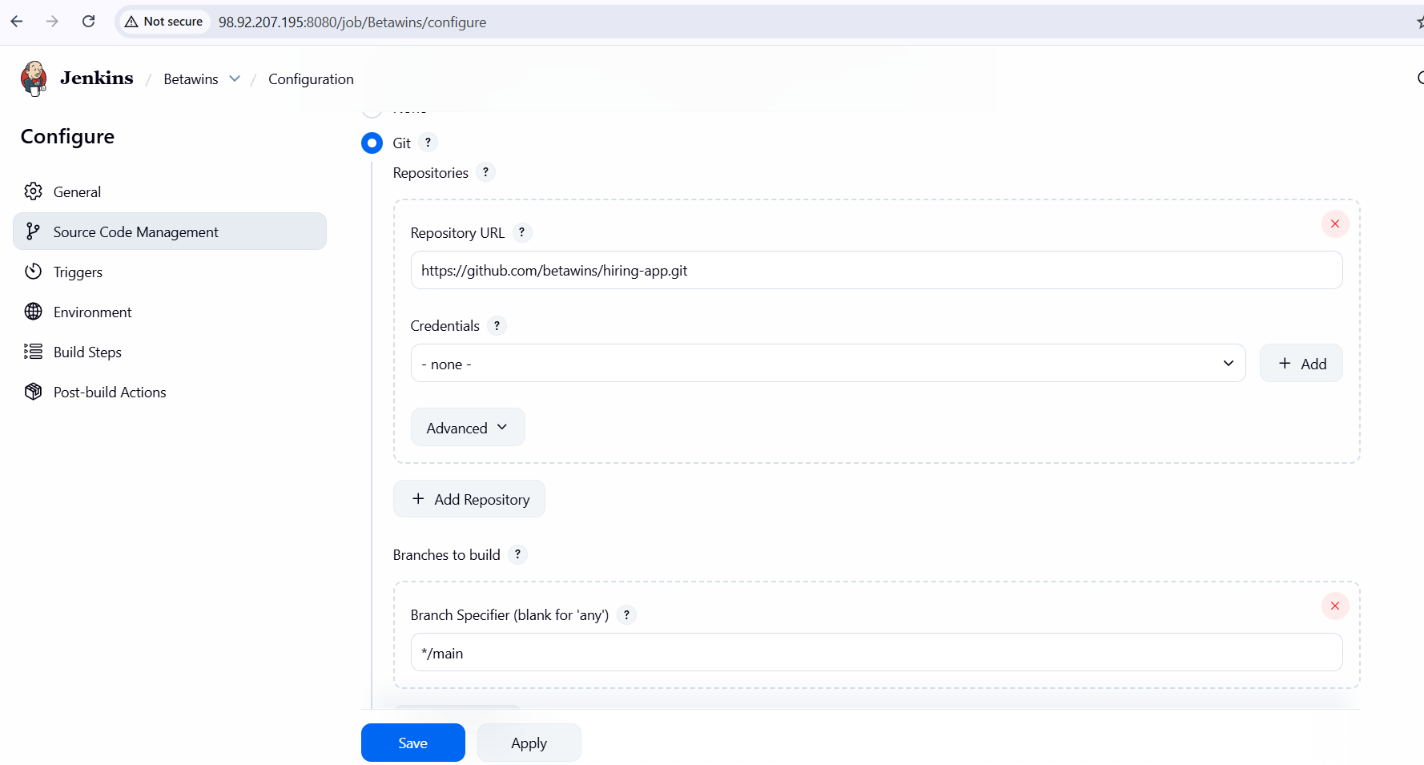
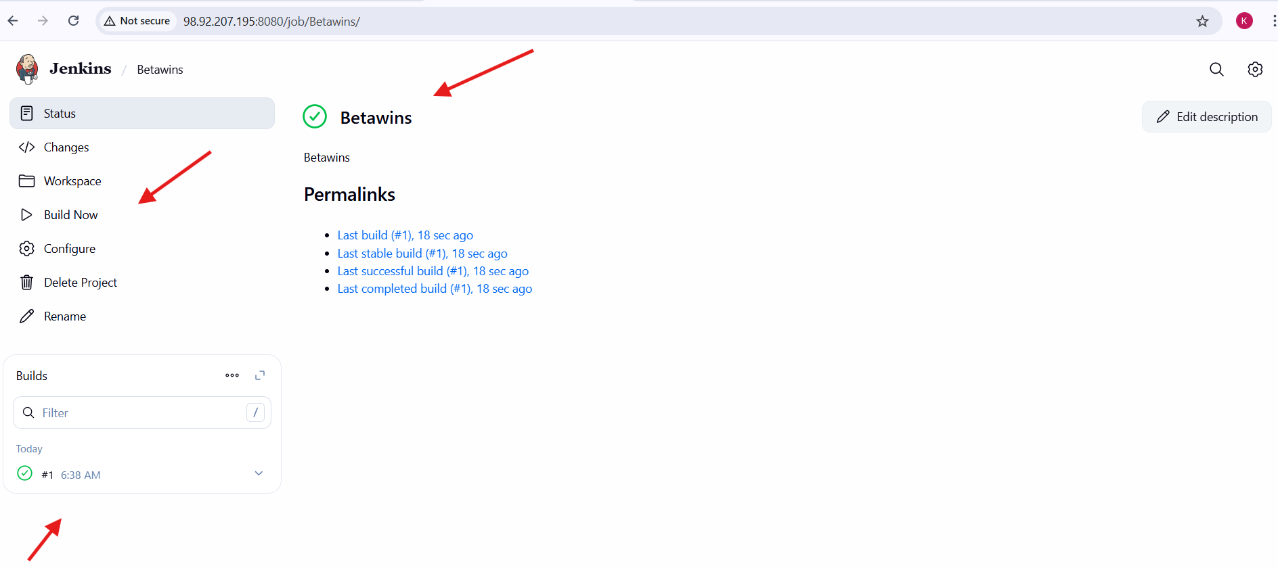
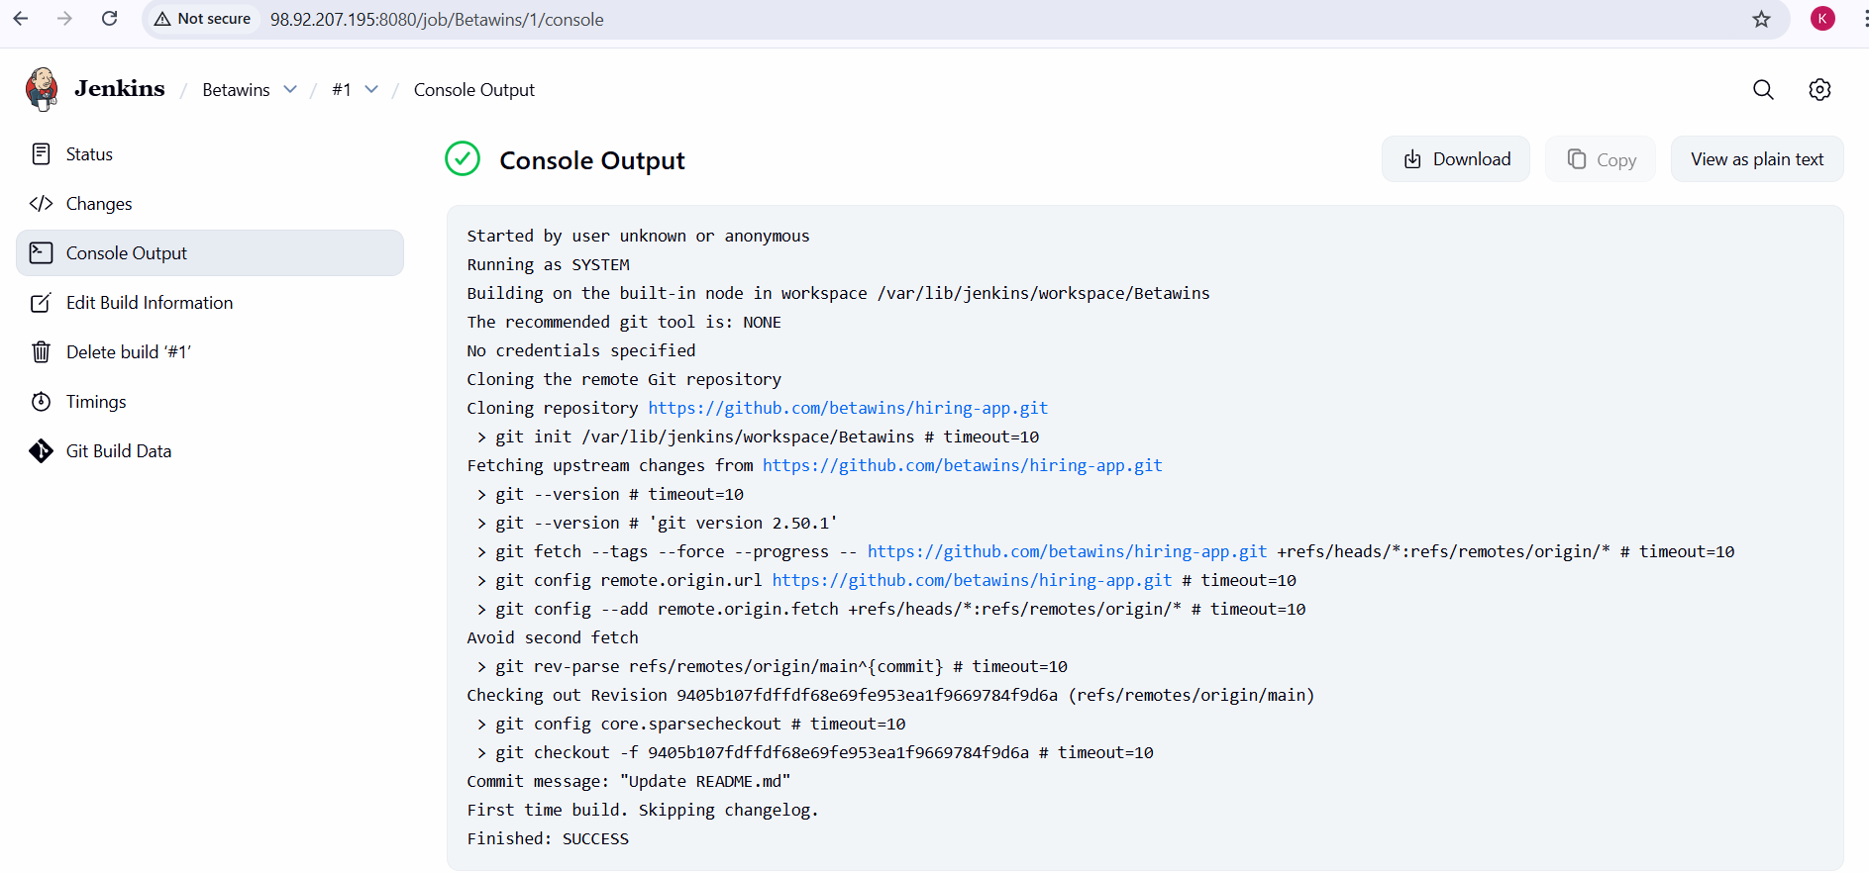

stage2: SonarQube Integration to check the quality of code.
Stage-2: SonarQube Integration – Steps Performed
Docker Installation
- Logged in to the EC2 instance as root.
- Installed Docker using the YUM package manager.
- Docker and required dependencies were installed successfully.
Docker Service Configuration
- Started the Docker service.
- Enabled Docker service to start automatically on system reboot.
- Verified Docker service status to ensure it was running.
SonarQube Image Setup
- Pulled the official SonarQube Docker image from Docker Hub.
- Created and started a SonarQube container.
- Mapped host port 9003 to container port 9000.
- Verified the running container using Docker commands.
SonarQube Web Access
- Opened a browser and accessed SonarQube using the server IP and port 9003.
- Logged in to SonarQube as Administrator.
SonarQube Token Generation
- Navigated to My Account → Security in SonarQube.
- Generated a Global Analysis Token named sonar_u...
- Copied the generated token for Jenkins integration.
Jenkins Credentials Configuration
- Logged in to Jenkins.
- Navigated to Manage Jenkins → Credentials → System → Global credentials.
- Added a new Secret Text credential.
- Stored the SonarQube token with ID sonar_un...
SonarQube Configuration in Jenkins
- Navigated to Manage Jenkins → System.
- Added a SonarQube server under SonarQube installations.
- Provided the SonarQube server URL.
- Selected the authentication token sonar_uncle.
- Saved the configuration.
Jenkins Job Execution
- Opened the Jenkins job Betawins.
- Triggered the job using Build Now.
- Jenkins executed the SonarQube analysis during the build.
Quality Gate Verification
- Observed SonarQube Quality Gate: PASSED in the Jenkins job page.
- Confirmed the build status was SUCCESS.
SonarQube Dashboard Validation
- Navigated to Projects in SonarQube.
- Verified the analyzed project was listed.
- Confirmed code quality metrics and overall status were displayed correctly.
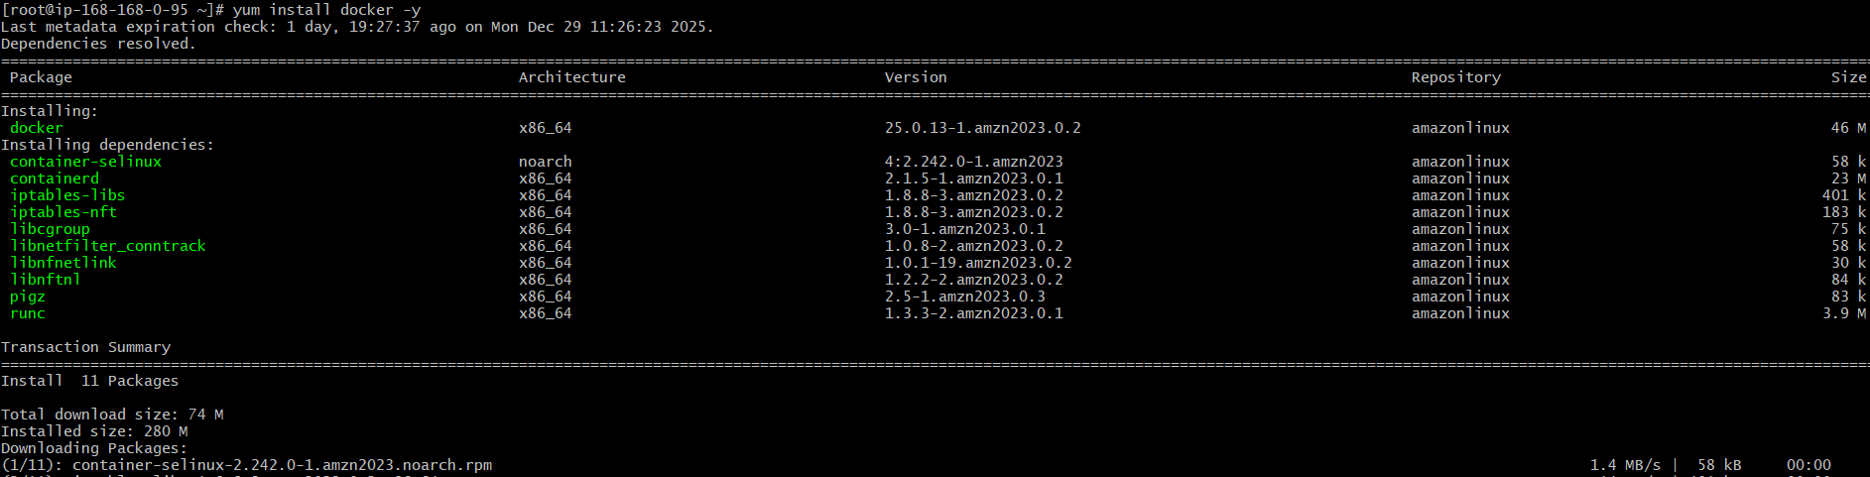
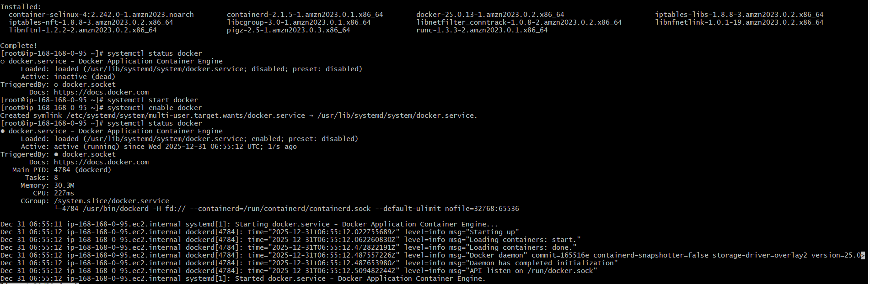
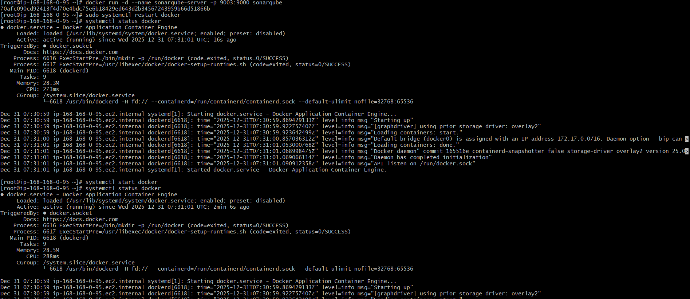
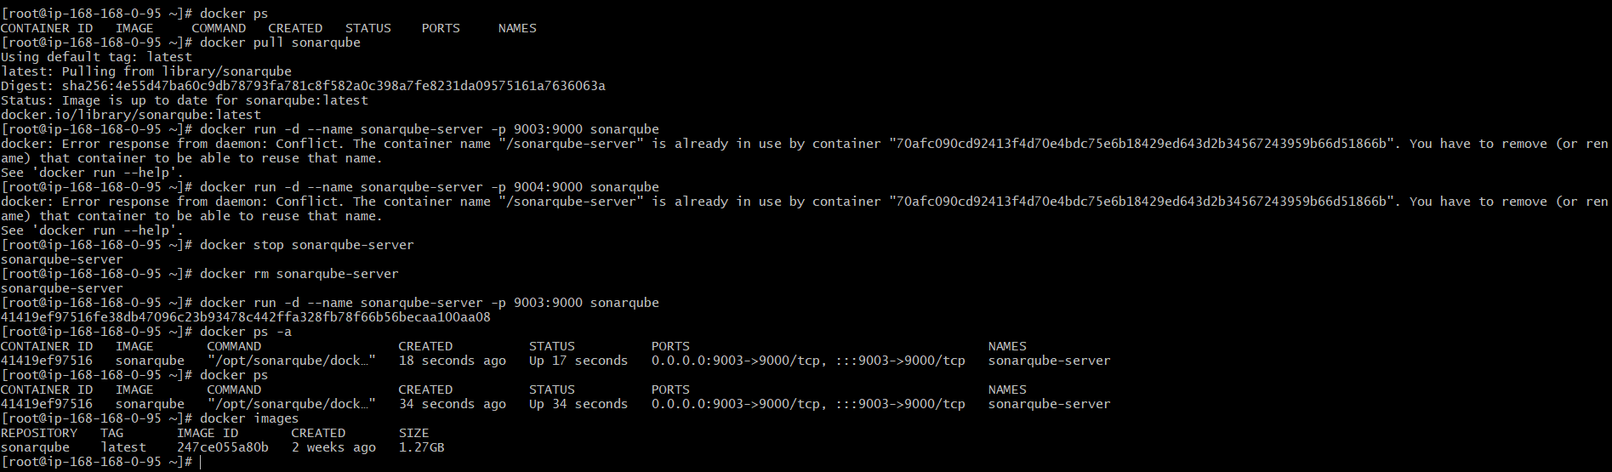
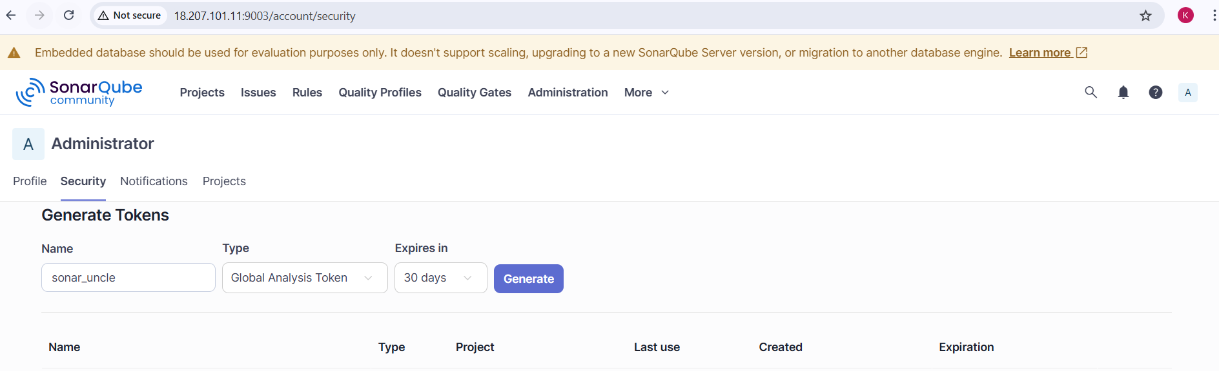
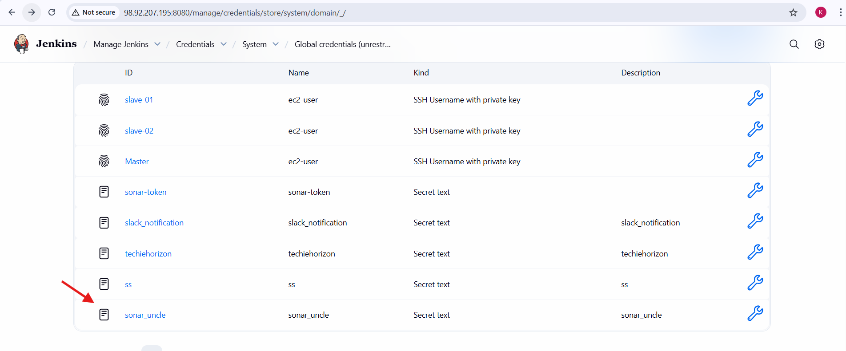
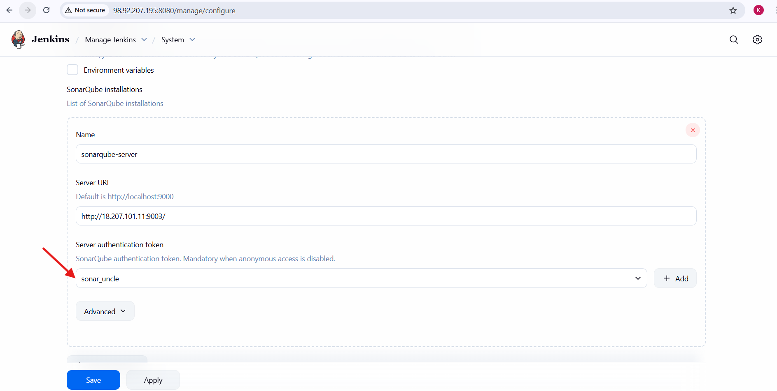

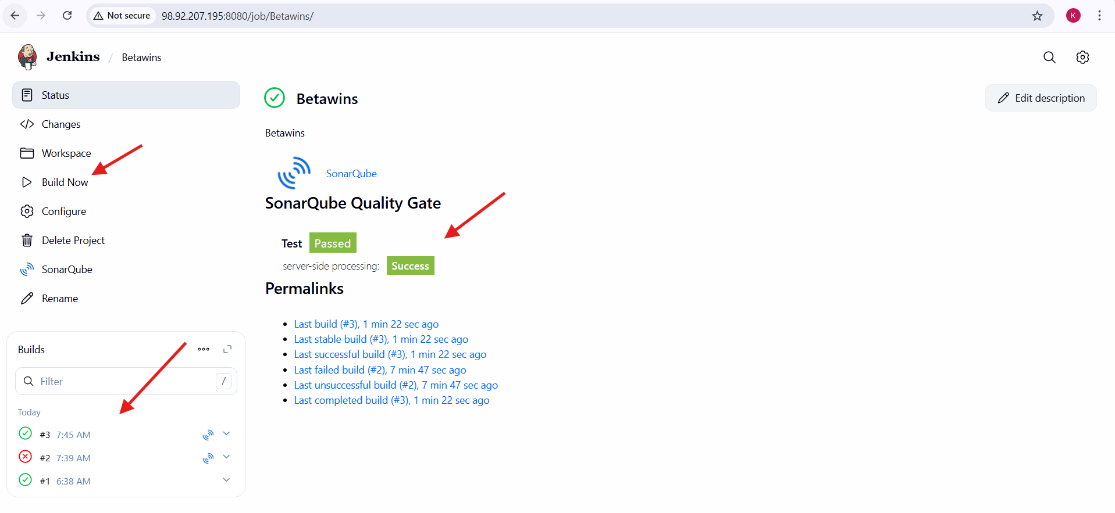
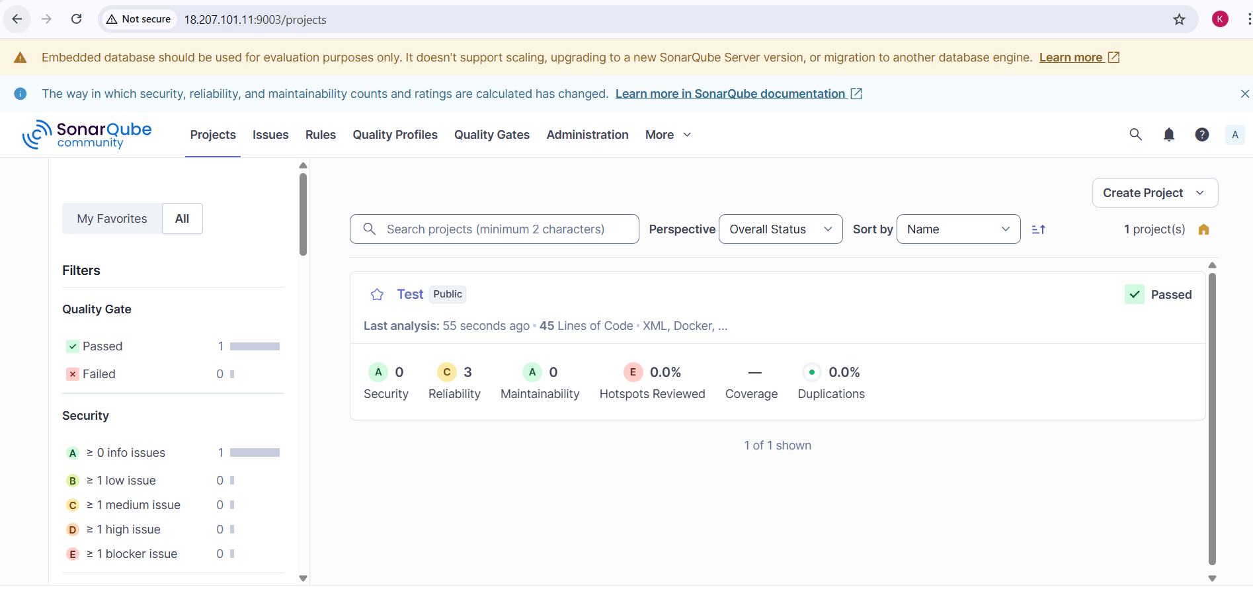

Stage3: Slack Integration to send the alerts to slack.
Configure Slack Notifications in Jenkins Job
- Opened Jenkins job Betawins.
- Navigated to Configure → Post-build Actions.
- Added Slack Notifications as a post-build action.
- Enabled the following notification options:
  - Notify Build Start
  - Notify Success
  - Notify Every Failure
- Left other notification options unchecked.
- Saved the job configuration.

Trigger Jenkins Build
- Navigated to the Betawins job dashboard.
- Clicked Build Now to trigger a new build.
- Jenkins started a new build and executed the pipeline.
Slack Notification Verification
- Opened Slack channel #jenkins-integration.
- Verified Jenkins notifications appeared in Slack:
  - Build started notification
  - Build success notification
- Notifications included:
  - Job name (Betawins)
  - Build number
  - Build status (Success)
  - Execution duration
Multiple Build Validation
- Triggered multiple builds of the Jenkins job.
- Observed Slack notifications for each build.
- Confirmed alerts were sent consistently for:
  - Build start
  - Build success
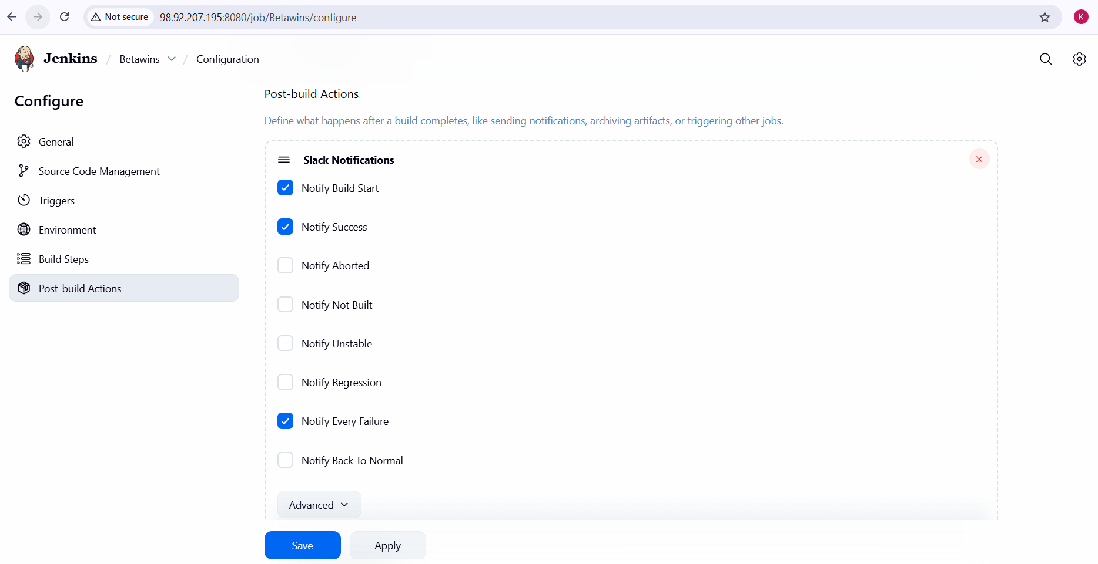
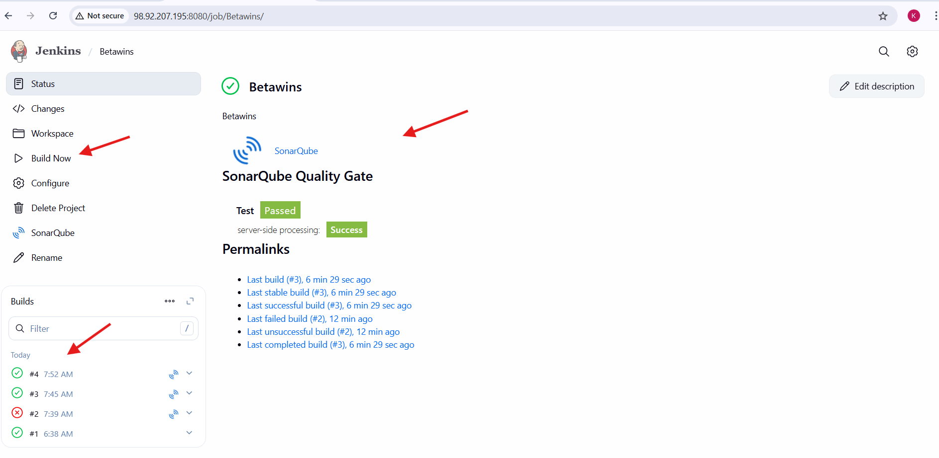
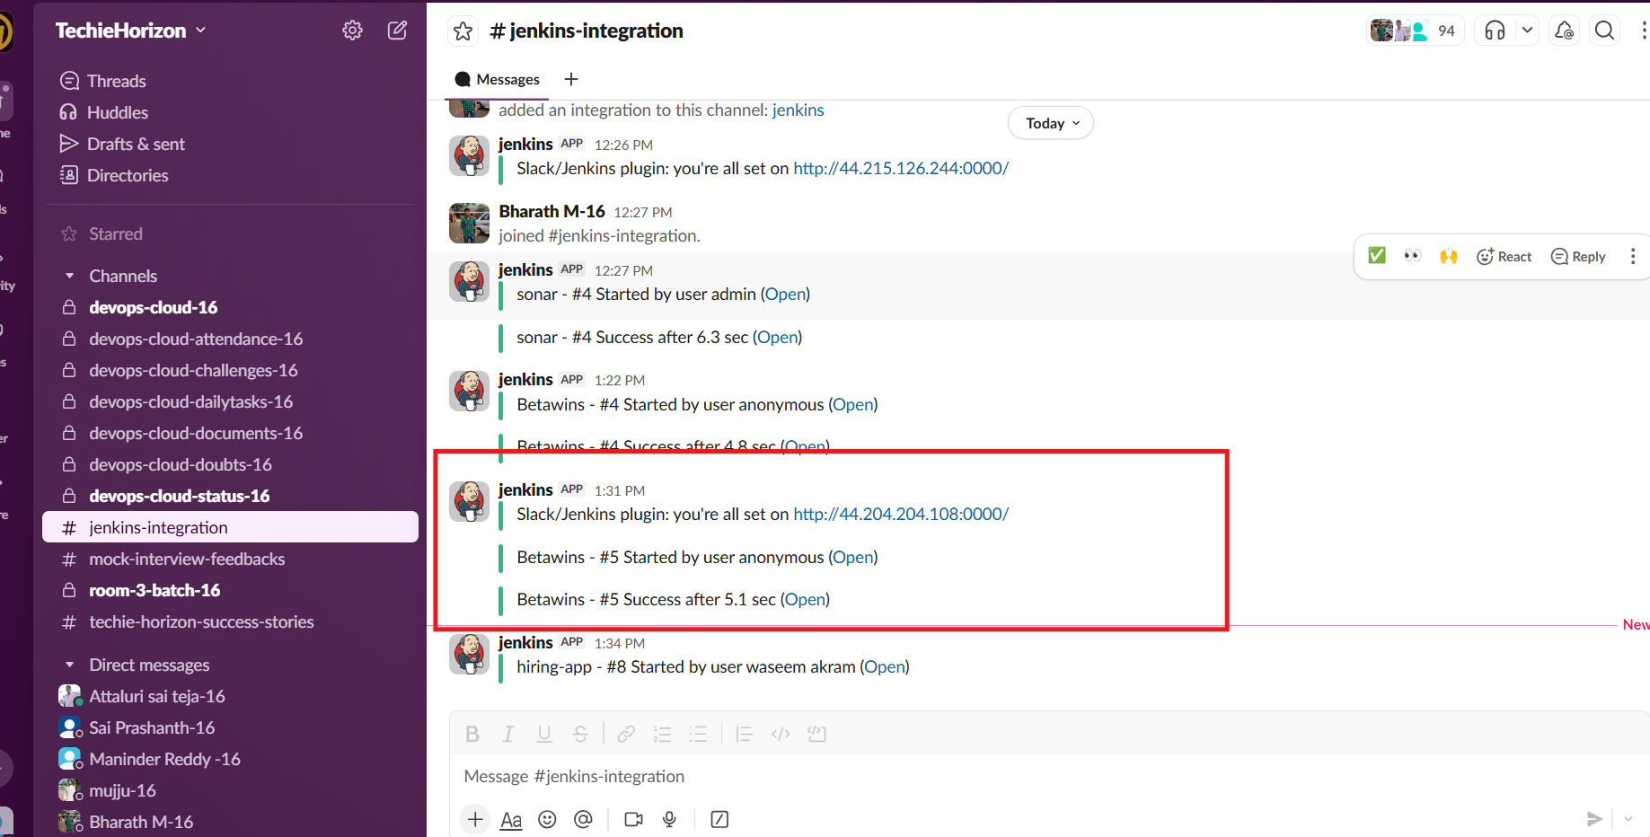

Overall Tasks Validation Steps:
- Jenkins job successfully cloned the GitHub repository.
- SonarQube analysis completed without authorization errors.
- Quality Gate status displayed as PASSED in Jenkins.
- Project appeared in SonarQube dashboard with code metrics.
- Slack channel received notifications for:
  - Build start
  - Build success
- Jenkins build status showed SUCCESS.

Overall Task Issues / Errors Faced:
- SonarQube authorization error due to missing token
  - Resolved by generating a SonarQube token and adding it to Jenkins credentials.
- Docker container name conflict while starting SonarQube
  - Resolved by stopping/removing the existing container.
- Slack notifications showing “anonymous user”
  - Caused by Jenkins security configuration and default Slack plugin behavior.
- Port accessibility issue
  - Resolved by allowing port 9003 in the EC2 security group.

Overall Task Conclusion:
The Jenkins job was successfully created with three integrated stages: GitHub source code retrieval, SonarQube code quality analysis, and Slack notifications. This setup ensures automated quality checks and real-time build status communication, improving code reliability, visibility, and CI efficiency. The task demonstrates an end-to-end CI pipeline aligned with DevOps best practices.

